Software Development Life Cycle (SDLC), Modularization, and Program Design

Alyssa Ramos-Stonecipher
13P-Spring 2026-Computing Logic OLCP
SDEV120 - Computing Logic
Prof. Chet Cunningham
January 22, 2025

In this paper, I will be using a Mobile To-Do list application as an example. For simplicity, I will be referring to this imaginary application as ToDoIT.

“The Software Development Life Cycle (SDLC) is a methodology with a clearly defined process for creating high-quality software.” (Stackify, 2024). The Life cycle contains 6 essential components and steps. All of these steps are crucial for developing high-quality software.
I will explain this in cascading order. The steps can be shown in the following image of the SDLC process. (See Figure 1) Notably, there are a few reputable versions of the SLDC around. Some even display up to 7 steps. I will be using a source provided on the Module 2 Learning Activities page. For simplicity, I will only explain and refer to the chart shown in Figure 1 by geeksforgeeks.com. The explanation of this specific developmental process can be applied to all charts, as they all have the same rhetoric.

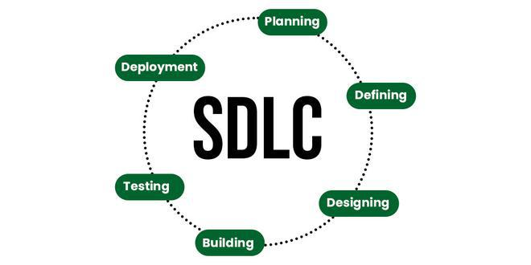
Figure 1. by GeeksForGeeks, ca. 2025

The first step in the SDLC is “Planning.” Planning is a crucial step to the start of the SDLC. This step in development is for planning your logic. What is the problem that needs to be solved, and what do we need from the solution? How much will the project cost? What is feasible from our team's skills and current abilities? All of these points need to be established during the first step of the SDLC. This step is to plan for your program and know what needs to be done. The Mobile Application ToDoIT needs to have a functionality to list the users' To-Do lists. If done independently, the cost should be minimal, as this is a single-person project.

The next step is labeled as “Defining” (Analysis). This is where requirements need to be defined. ToDoIT is required for a user to list their errands and mark them off. This is where we decide how we will get what we want. The independent at ToDoIT will review the plan and confirm that no additional information is needed. If ToDoIT had stakeholders, this would be when the plan is reviewed with them for any input.

Now is the time to code. This step is ‘Designing.' This is where we build relationships between modules, design a database, and more. This is where our software will run. The key players for this role would be System Architects and Lead Developers.

This next step is “Building” (Implementation). Actual development for the project has started here. This is when the developer sticks to the agreed-upon blueprint. If working in a team, be sure to follow the code style and practices guidelines. Key players in this cycle are the Frontend, Backend, and full-stack developers. Lucky for us at ToDoIT, we have only one person to do all the hard work for us.

The next step is ‘Testing.” This is where each function is tested. This is to ensure the modules work together. The goal is to find any bugs or security issues before the customer does. This is also a good point to make sure that the software is doing what it was intended to do. Here at ToDoIT, we will make sure that the user has the ability enter an errand and to mark it off. What if a user inputs their errand and it disappears from the app? This needs to be addressed before the next step, as this does not adhere to the requirements.

The next and final step is “deployment”. This is the deployment to the customer(s). This is when the application goes live and can be used for its intended purpose. ToDoIT fixed the bug, released the program to the app store, and users now have a convenient place to store their errands.

There is an additional step not listed on the graphic, but it is very important and necessary for the rest of the software’s continued life; this is maintenance. Software maintenance involves releasing patches or updates. Perhaps there is a bug that was found and needs to be patched that wasn’t found in the “Testing” stage. Better yet, what if ToDoIT added the ability to color-coordinate errands? This is where the process is ongoing, but thankfully slower!

As mentioned earlier, there are multiple models describing the SDLC. One of the models is the iterative model. The iterative model emphasizes repetition. Developers using this model will develop rapidly and at low cost, test and improve it through rapid iterations. This is great in theory, but if left unchecked, this process can use a ton of resources fast! Although this would help projects release faster, it may miss bugs or implementation details.

On the other hand, developing a prototype is what a project should look like or behave like when it’s done. This could also be crucial for identifying what may need to be improved, added, or removed. This type of development can give the team hindsight it may not have had before. This is different from the iterative model, as this is not low-cost or rapidly developing. Developing a prototype can take a lot of time and resources, but it gives hindsight.

At ToDoIT, using the Iterative Model would allow us to develop the application quickly and on a low budget. This could be great for ToDoIT, as this is a single-person project. The developer is not getting paid or commissioned for this. The Developer may need stipends soon and would like to release this application as soon as they can. On the contrary, this could mean missed opportunities for adding special features or bugs that may impact the Users’. If ToDoIT decided to use the prototype method, it would mean building a ‘fake’ app to see where improvements can be made in the development process. This could mean a larger incentive for Users to purchase the ‘Premium’ Version if there are extra features developed only found in the Prototype stage with that special hindsight.

Modularization is the process of designing and building complex systems for our code. This acts as a folder; in a folder. This also allows multiple programmers to work on a large project. Dividing large tasks into smaller modules makes it easier to assign them to multiple people. Rarely does a single developer write a commercial program; often it is assigned to different developers or teams. Modularization also allows for the reuse of work. The same module could be used across multiple applications. This also ensures that different pieces of code are reliable, since they have already been tested and proven to function correctly.

Modularization is also scalable, as you can reuse code, put a module aside, and work on a different piece of code. This, in the end, yields a cohesive codebase that is compiled into an application.

References and Sources (2):
Stackify Team (2024, June 10). What Is SDLC? Understand the Software Development Life Cycle. Stackify.com, https://stackify.com/what-is-sdlc/

Geeksforgeeks Team (2025, December 9). Software Development Life Cycle (SDLC).
geeksforgeeks.org, https://www.geeksforgeeks.org/software-engineering/software-development-life-cycle-sdlc/

